4th Order Hairpin Bandpass Filter

# Youssef Samwel

# [yo800238@ucf.edu](mailto:yo800238@ucf.edu)

# EEL5437C Microwave Engineering

Prof. Dr. Xun Gong - Section 0012

12/10/2023



# Objective

Design a 4th order Chebyshev filter 3.6 GHz using half-wavelength hairpin structure with ripple bandwidth of 0.24 GHz and passband S11 below -15 dB.

# Resonator Synthesis

From microwave theory we know that a transmission line terminated with opens on both ends will be resonant at half the guided wavelength. The guided wavelength is determined from effective epsilon and trace characteristic impedance. For this filter, the desired resonance was at 3.6 GHz; given this constraint we can compute the guided wavelength of a microstrip transmission line using the following method.

The first critical step in the synthesis of the resonator is determining the copper trace width. To compute the dimensions of microstrip line I used an online calculator [https://www.pasternack.com/t-calculator-microstrip.aspx] and was able to compute a width of 1.78mm for a 50 $Ω$ transmission line.

Given that the substrate is a Roger’s RO4003C with a dielectric constant of 3.55 and height of 31 mil (.7874 mm); we can compute the effective dielectric constant using the following equation,

$$ϵ_{eff}=\frac{ϵ_{r}+1}{2}+\frac{ϵ-1}{2\sqrt{1+12\frac{H}{W}}} If \left(\frac{W}{H}\right)>1$$

$$ϵ_{eff}≈2.784$$

Now we can compute the ideal resonator length,

$$\frac{λ}{2}=\frac{c_{0}}{f_{0}\sqrt{e_{eff }}}=24.96 mm$$

Given this information we can simulate the resonator in HFSS, the following is resonator structure,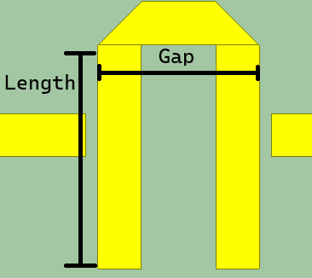

Figure 1, Hairpin Structure

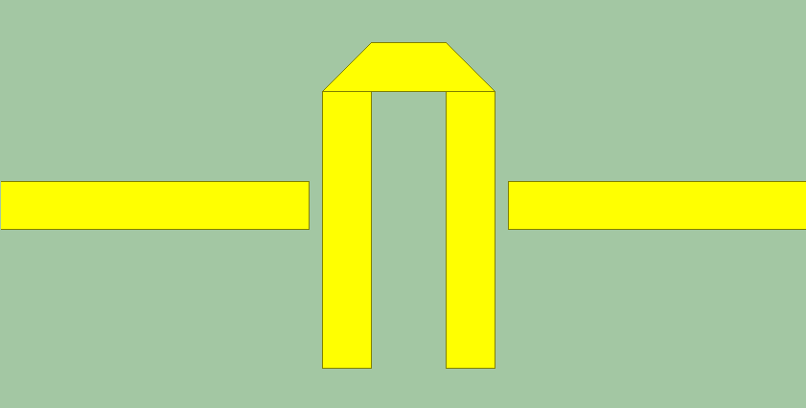

Figure 2, Weakly Coupled Resonator

The initial total length of the resonator half wavelength but this does not determine the ratio of the gap to the length. I performed a sweep of the gap and length; the following is the simulated peaks.

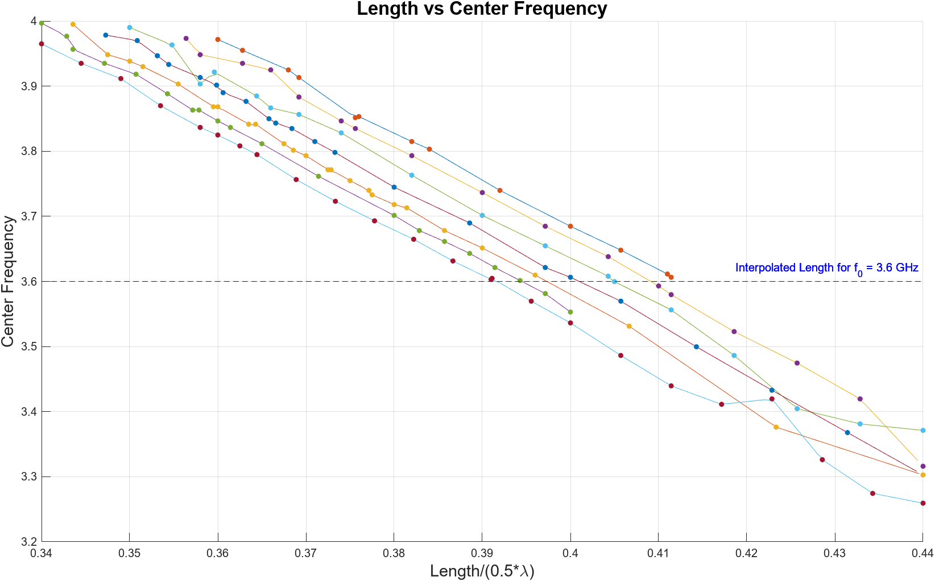

Figure 3, See Program 1 and Program 2

The following are simulations performed at the interpolated length for 3.6 GHz,

|  |  |  |
| --- | --- | --- |
| Gap (mm) | Length (mm) | Offset from $f_{0}$ (GHz) |
| **5.99** | 10.27 | 0.0063 |
| 6.11 | 10.23 | 0.7000 |
| 6.29 | 10.11 | 0.0003 |
| 6.44 | 9.98 | 0.0063 |
| 6.61 | 9.88 | 0.0097 |
| 6.74 | 9.84 | 0.0097 |
| 6.86 | 9.76 | 0.0030 |

The following are the dimensions of the simulated structure: Trace width: 1.78 mm, Probe length: 11.03 mm, Resonator length: 24.96 mm, substrate thickness: 31 mil, substrate width: 16mm, substrate length: 50mm Gap: 6.29mm, Length: 10.11 mm.

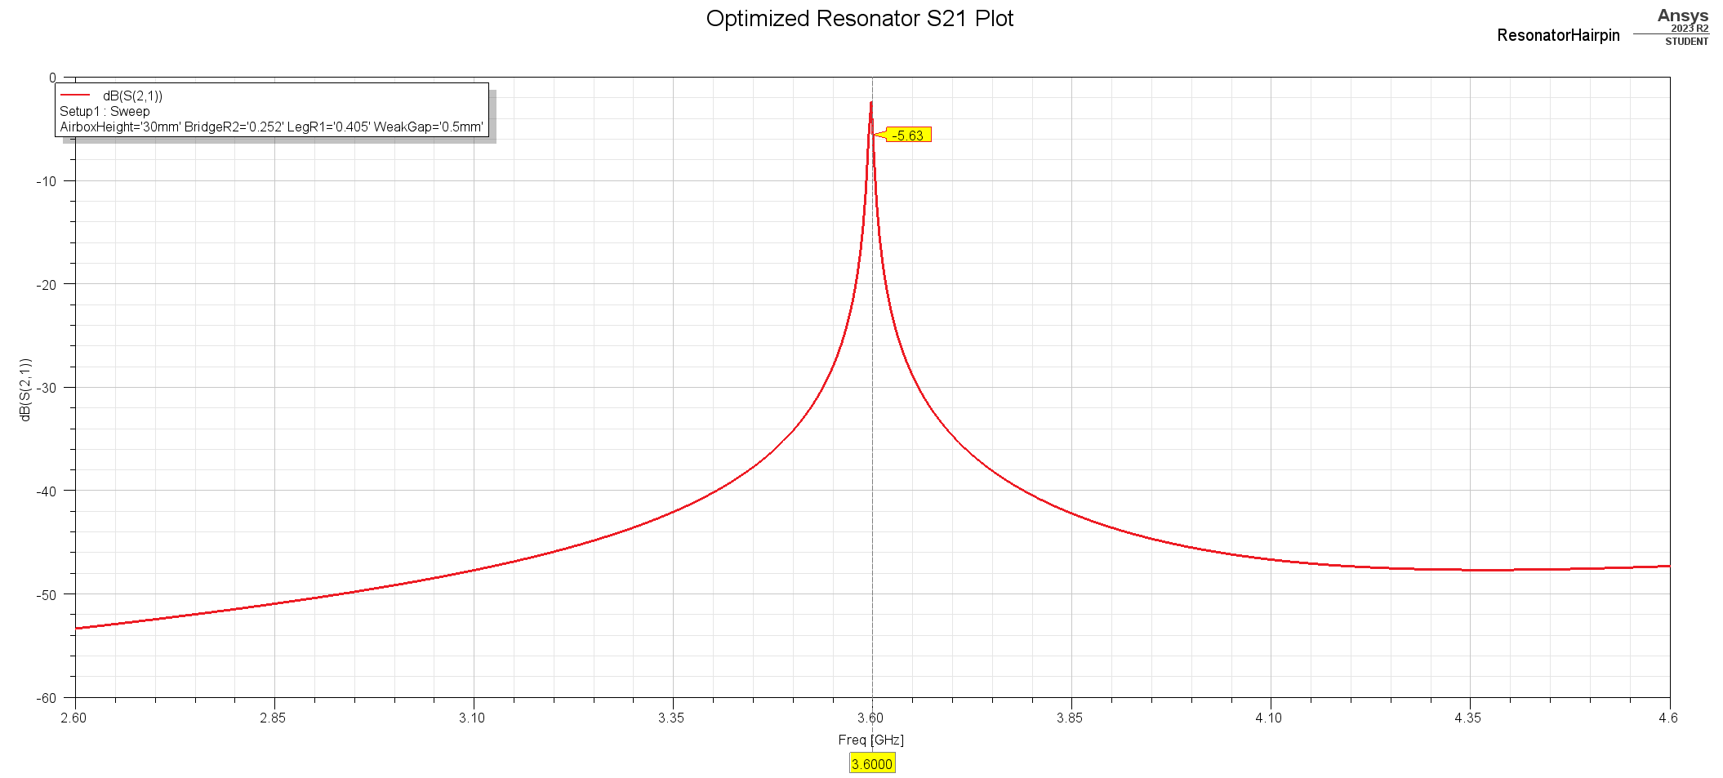

## 2.5 Encountered Difficulties

In my initial attempt at resonator synthesis, I endeavored to weakly couple the resonant frequency within the range of -30 to -40 dB, as suggested by Dr. Swanson's paper. However, this approach presented several challenges. First and foremost, the structure exhibited instability in response to even minor alterations. For instance, while anticipating a decrease in the center frequency with reduction to length variables, I observed random fluctuations in the center frequency instead. Furthermore, I observed an excessive sensitivity to the tapping position. I attribute this instability to convergence issues.

Upon examining the convergence plot in HFSS, it became evident that the simulation reached the target maximum S delta. However, increasing the pass count resulted in a significant rise in the max S delta, as illustrated in the accompanying plot.

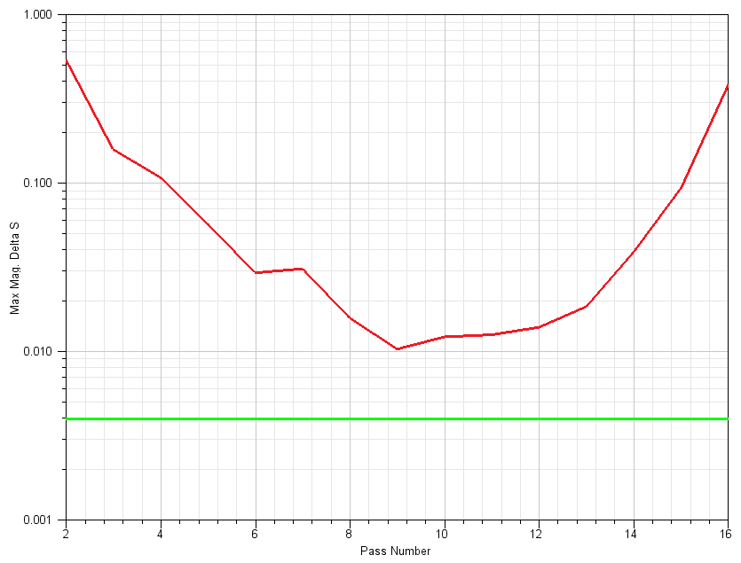

Upon recognizing this, I opted to increase the pass count, but this decision brought about two notable issues. Firstly, the simulations started consuming considerably more time to complete, and secondly, I encountered the limitation of the maximum tetrahedral count permitted by the student version of HFSS. Despite these constraints, I managed to identify the optimal values for both "Gap" and "Length." Nonetheless, an anomaly surfaced in the S21 plot, deviating from the expected behavior.

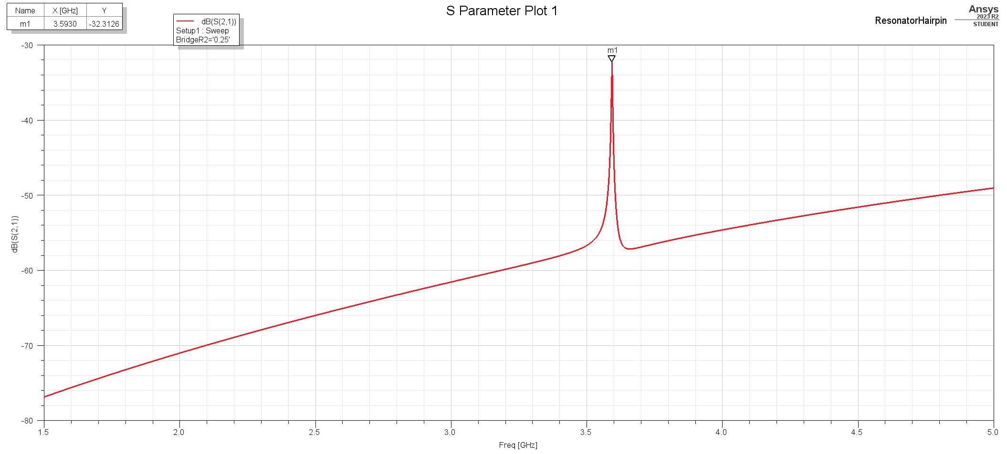

S21 using -32 dB weak coupling.

To address these challenges, I made the strategic choice to increase the coupling strength in order to mitigate the structure's sensitivity. The increased coupling strength resulted in significantly improved stability during simulations. Subsequently, the simulations for the subsequent steps exhibited a more coherent alignment with the findings in Dr. Swanson's paper.

# Filter Synthesis

# 3.2 Lumped Element Bandpass Filter

The initial step in filter synthesis involves selecting the lowpass prototype table. For this project, I have opted for the identical table utilized in the Dr. Swanson paper, as illustrated below:

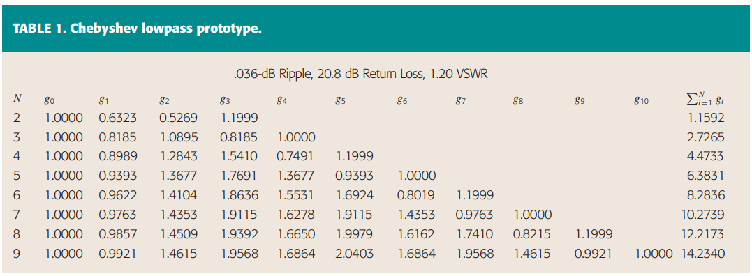

Utilizing the specified table, we can construct the bandpass filter to anticipate the characteristics of the hairpin filter. Presented below are the low-pass and bandpass lumped element filters:



Equivalent Low pass filter



Equivalent Bandpass filter transformed from low pass filter.

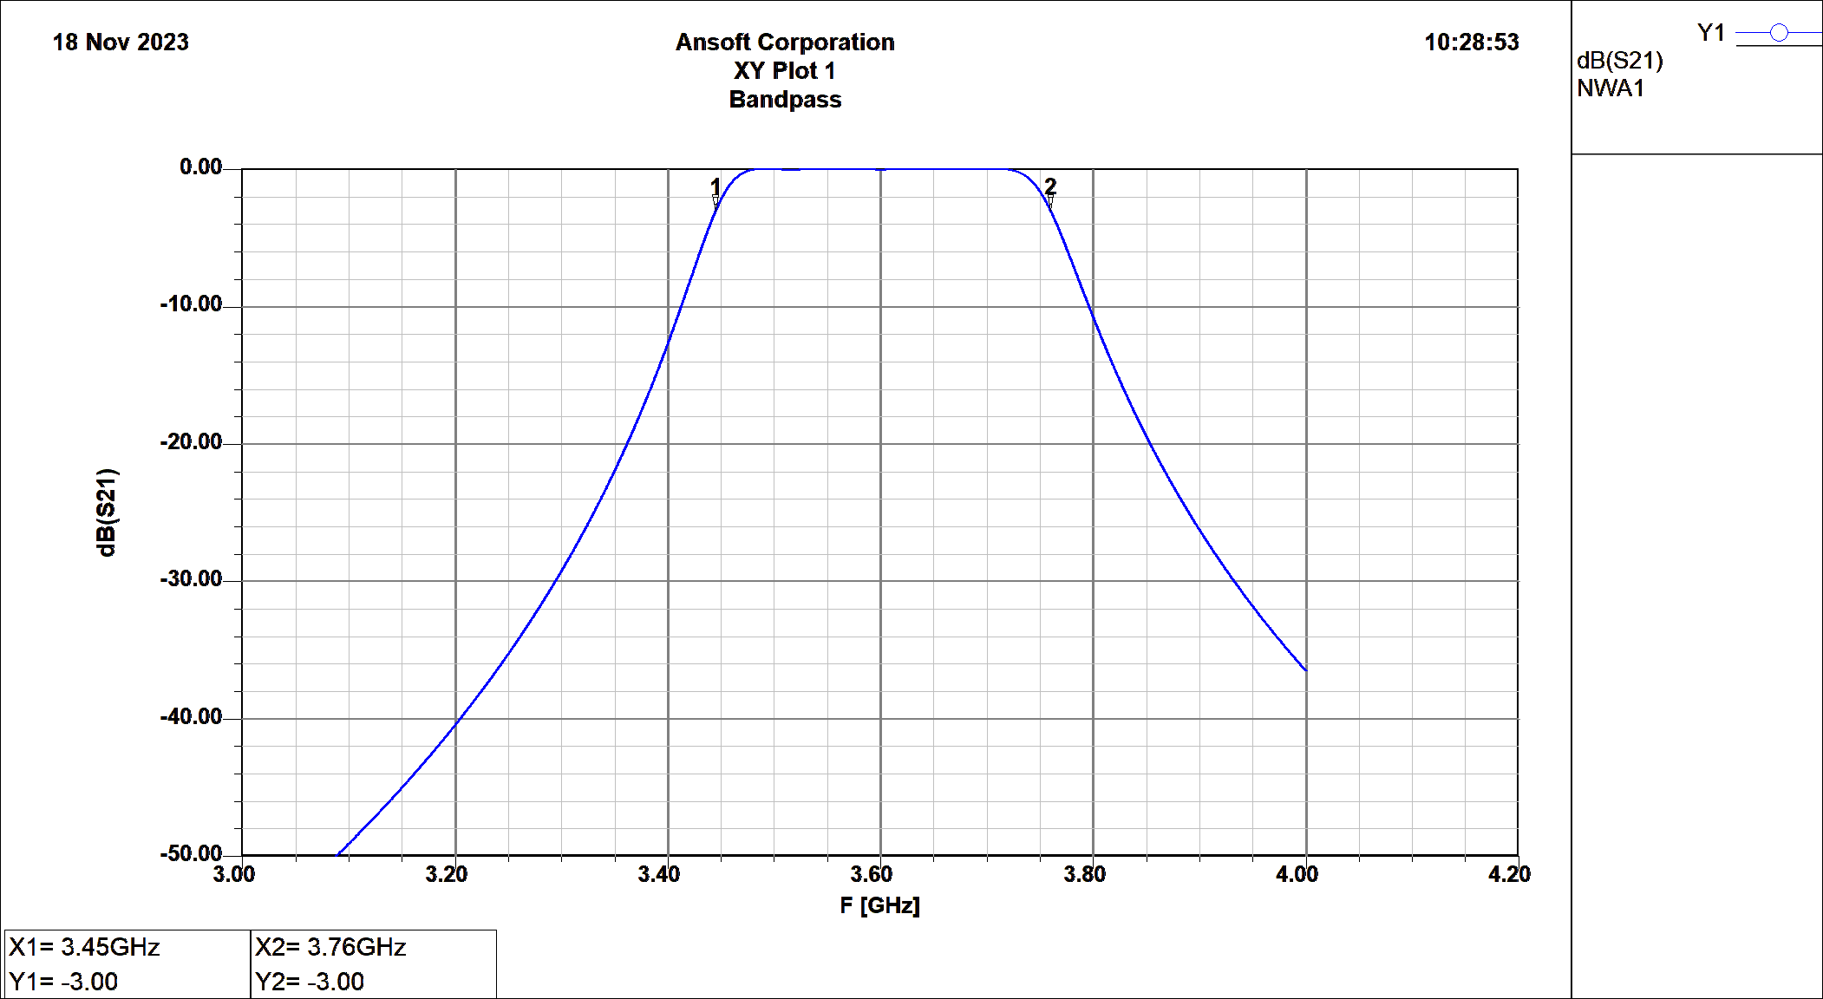

S21 dB Plot of Lumped-Element Bandpass filter

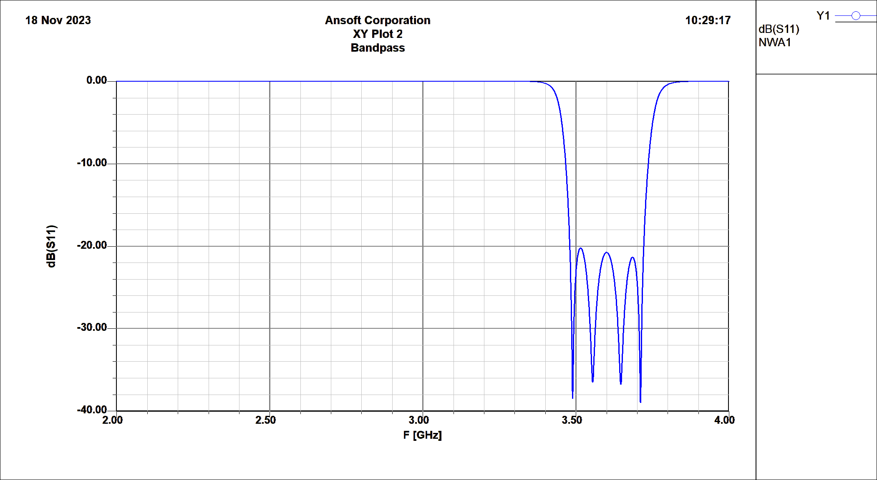

S11 dB Plot of Lumped-Element Bandpass filter

# 3.4 Internal Coupling Coefficient K

The desired internal coupling coefficient are computed from Chebyshev table in the following method,

$$k_{j,j+1}=\frac{Δ}{ω_{0}\sqrt{g_{j}g_{j+1}}}$$

Where $Δ$ is the ripple bandwidth and $ω_{o}$ is the center frequency. For our filter we have three coupling coefficients, $k_{1,2}$, $k_{2,3}$, and $k_{3,4}$.

$$k_{1,2}=0.062047$$

$$k_{2,3}=0.047389$$

$$k_{3,4}=0.062049$$

An important observation is that coupling between first and second resonator is the same as the third and fourth resonator, this allows us to have a symmetrical device. We can simulate the internal coupling coefficient by coupling two resonators and performing a sweep on the coupling distance.

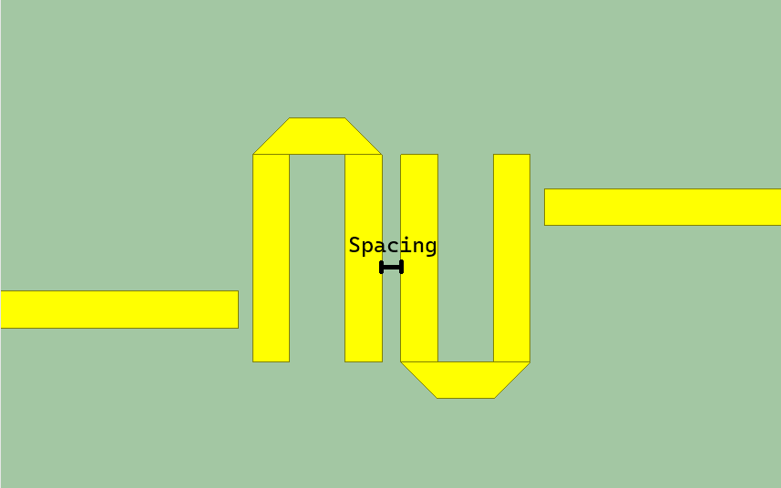

Structure used to simulate internal coupling.

Now, we can initiate a sweep on the spacing variable and utilize interpolation to ascertain the spacing necessary to achieve the desired coupling values. The subsequent results of the simulation sweep are as follows. The internal coupling values can be computed using the following equation:

$$k_{j,j+1}=\frac{f_{e}^{2}-f_{m}^{2}}{f_{e}^{2}+f_{m}^{2}}$$

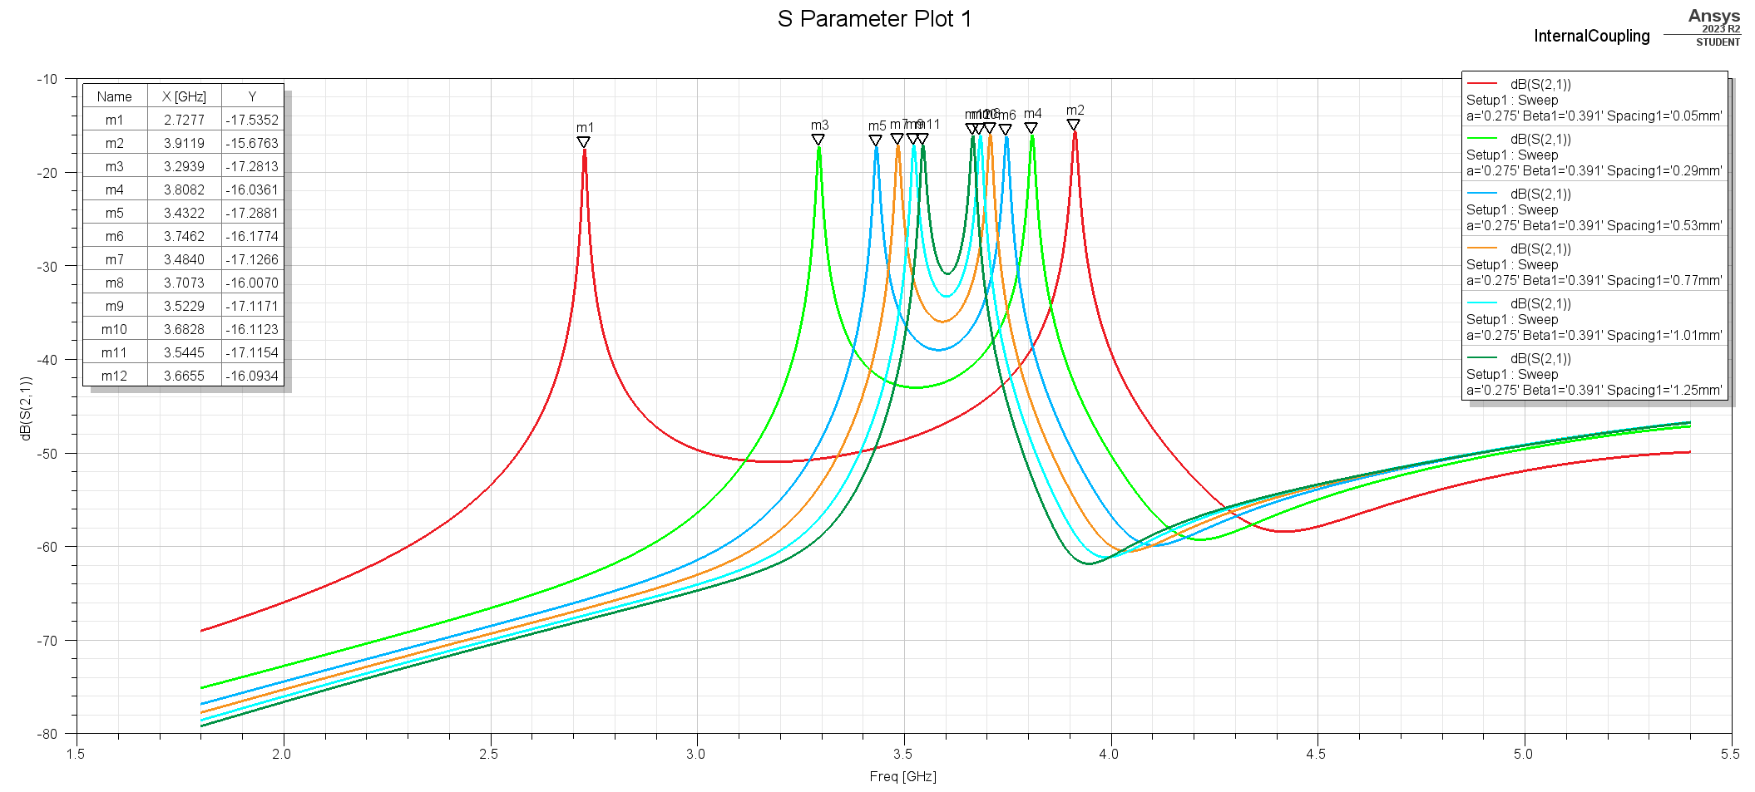

Sweep of spacing variable.

|  |  |  |  |
| --- | --- | --- | --- |
| **Spacing** | $$f_{m}$$ | $$f_{e}$$ | $$k_{ij}$$ |
| 0.05 | 2.7868 | 3.9479 | 0.334858 |
| 0.29 | 3.2881 | 3.8139 | 0.147264 |
| 0.53 | 3.4178 | 3.7405 | 0.089978 |
| 0.77 | 3.4797 | 3.7059 | 0.062897 |
| 1.01 | 3.5172 | 3.6814 | 0.045596 |
| 1.25 | 3.5431 | 3.6627 | 0.033186 |

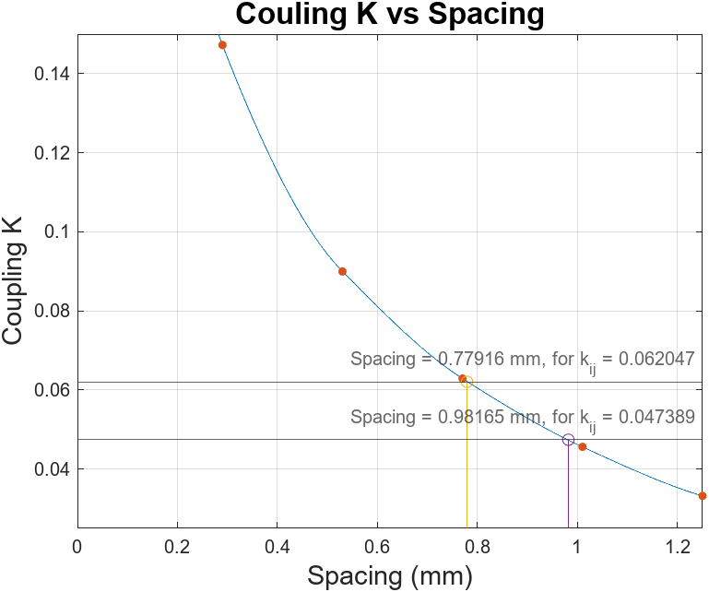

Plot of internal coupling and interpolated spacing values. See Program 3

The following values denote the interpolated spacings necessary to achieve the desired internal coupling:

|  |  |  |
| --- | --- | --- |
| $$k_{ij}$$ | Computed $k_{ij}$ | Spacing (mm) |
| 12 | 0.06205 | 0.77916 |
| 23 | 0.04739 | 0.98165 |
| 34 | 0.06205 | 0.77916 |

# External Coupling Coefficient $Q_{ext}$

The desired $Q_{ext}$ are computed from Chebyshev table in the following method,

$$Q_{ext_{A}}=\frac{ω_{0}g_{0}g_{1}}{Δ}, Q_{ext_{B}}=\frac{ω_{0}g_{4}g_{5}}{Δ}$$

$$Q_{ext_{A}}=13.484,Q_{ext_{B}}=13.483$$

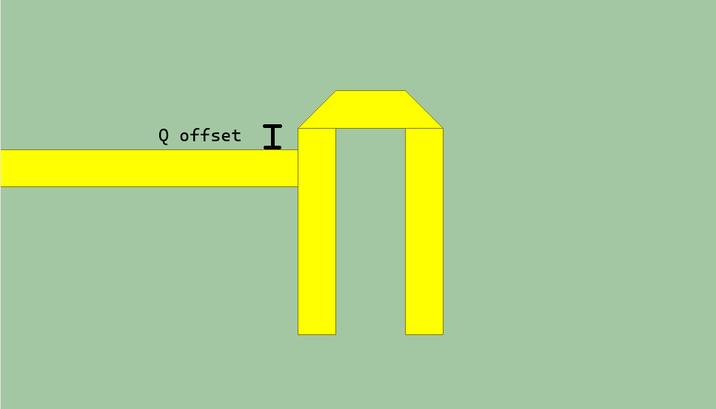

External Coupling Circuit (Single Port)

To attain the desired external coupling coefficient, we initiate a sweep on the Q offset variable. The external Q can be computed using the following equation:

$$\frac{1}{Q_{ext}}=\frac{1}{Q_{L}}-\frac{1}{Q_{U}}$$

By making the resonator lossless, specifically by eliminating the loss tangent of the Rogers 4003C material and switching the PCB material from copper to PEC, the computation of $Q_{U}$ becomes unnecessary, and we can directly measure $Q_{ext}$. To calculate $Q_{L}$ (which is equivalent to $Q_{ext}$ in this scenario), we divide the center frequency by the change in frequency at 180-degree differences, as illustrated in the following diagram.



Source: Dr. Xun Gong, Lecture 7 – Filter

The following is an example of $Q_{ext}$ measurement.

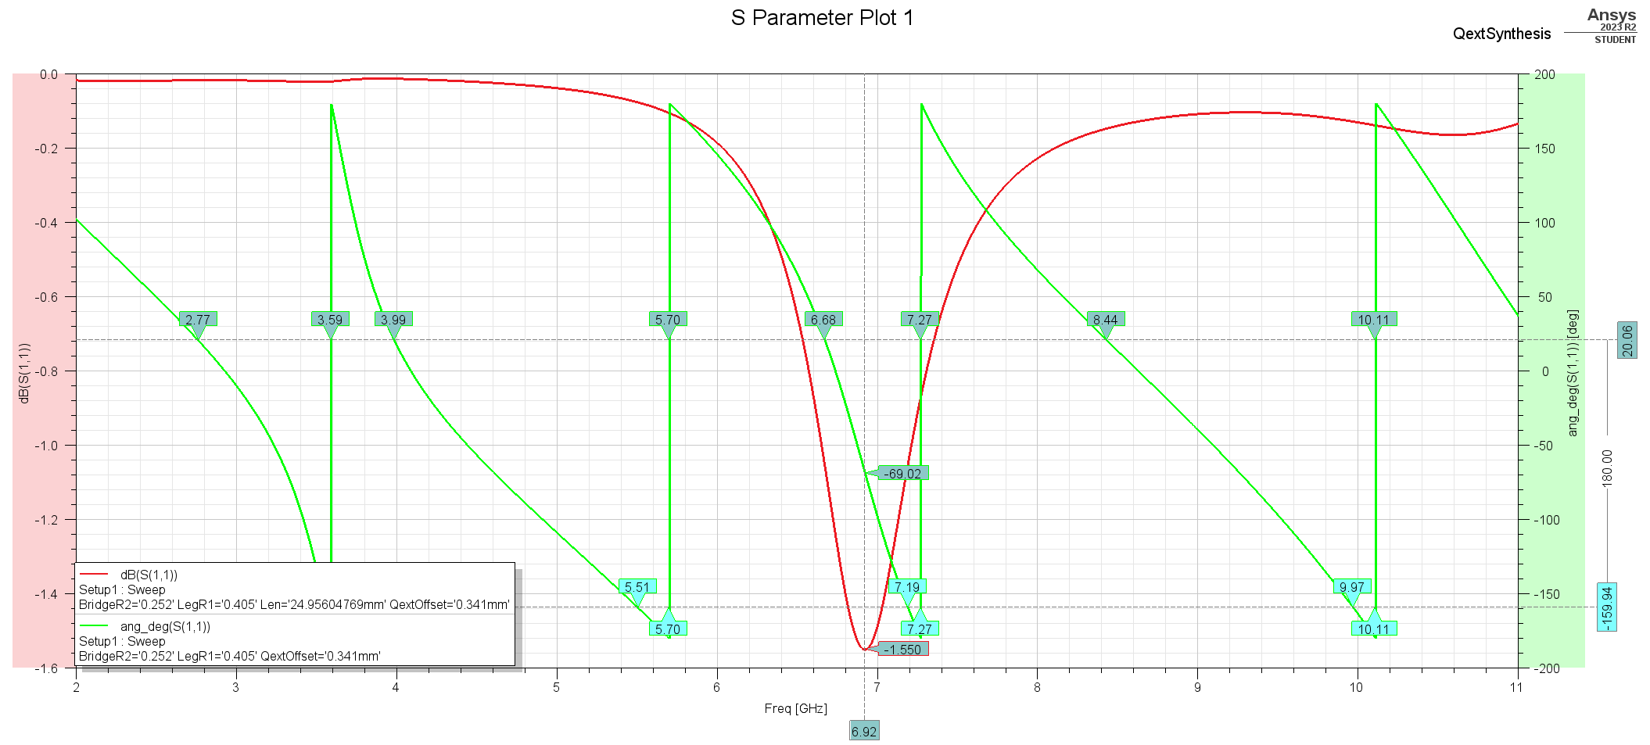

$Q_{ext}$ measurement at $Q_{offset}$ = 0.341 mm

|  |  |  |  |  |  |  |  |
| --- | --- | --- | --- | --- | --- | --- | --- |
| **Offset (mm)** | $$f_{0}$$ | $$f_{0}(θ)$$ | $$f_{1}$$ | $$f_{1}\left(θ\right)$$ | $$f_{2}$$ | $$f_{2}\left(θ\right)$$ | $$Q_{ext}$$ |
| **0.0** | 6.95 | -74.78 | 6.67 | -164.78 | 7.26 | 15.22 | 11.7797 |
| 0.1 | 6.94 | -71.9 | 6.67 | -161.9 | 7.24 | 18.1 | 12.1754 |
| 0.2 | 6.94 | -70.03 | 6.67 | -160.03 | 7.22 | 19.97 | 12.6182 |
| 0.3 | 6.89 | -68.47 | 6.64 | -158.47 | 7.16 | 21.53 | 13.2500 |
| 0.4 | 6.92 | -68.73 | 6.68 | -158.73 | 7.18 | 21.27 | 13.8400 |
| 0.5 | 6.89 | -64.15 | 6.66 | -154.15 | 7.14 | 25.85 | 14.3542 |
| 0.341 | 6.93 | -69.94 | 6.68 | -159.94 | 7.19 | 20.06 | 13.58824 |

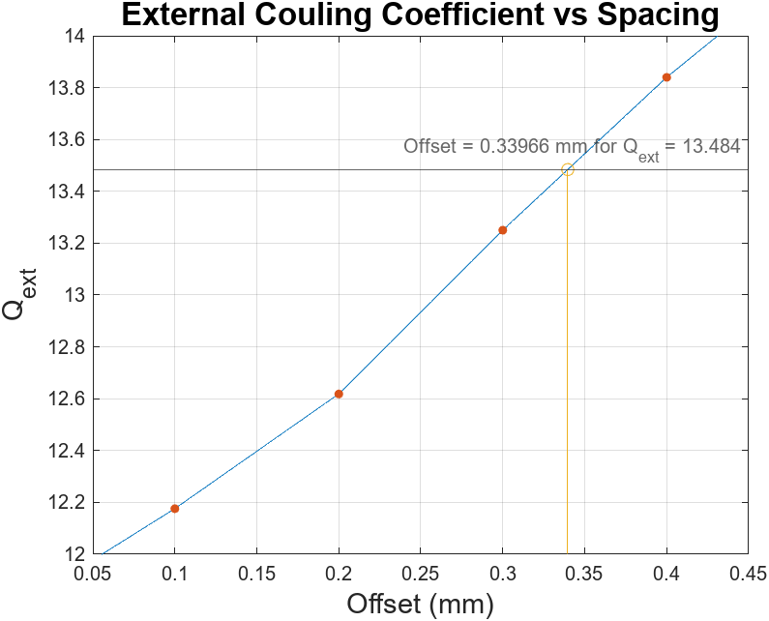

Plot of measured Q vs Offset.

# Tuning and Filter Fabrication

Once we have the external and internal coupling, we can construct the 4th order filter as shown in the following image.

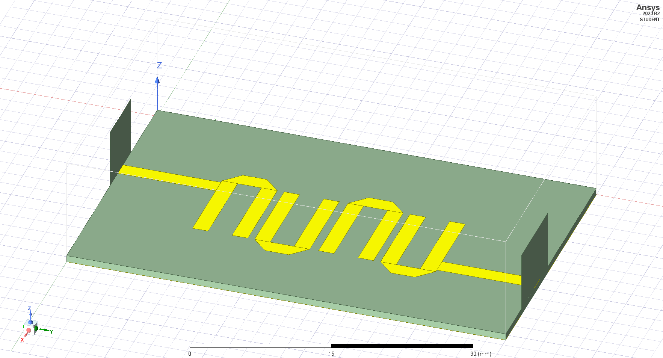

Initial Filter Structure

The following is S21 and S11 plot response,

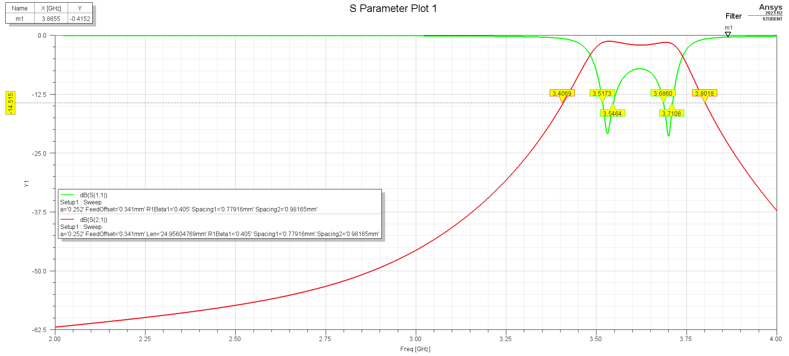

The initial filter has the correct center frequency, but the passband is clearly above the specification of -15dB.

In the tuning process for this filter, I adopted capacitor tuning based on the methodology outlined in Dr. Swanson's paper. To apply this method, it is imperative to include four additional ports for adjusting both the resonator's length and internal coupling, as illustrated below:

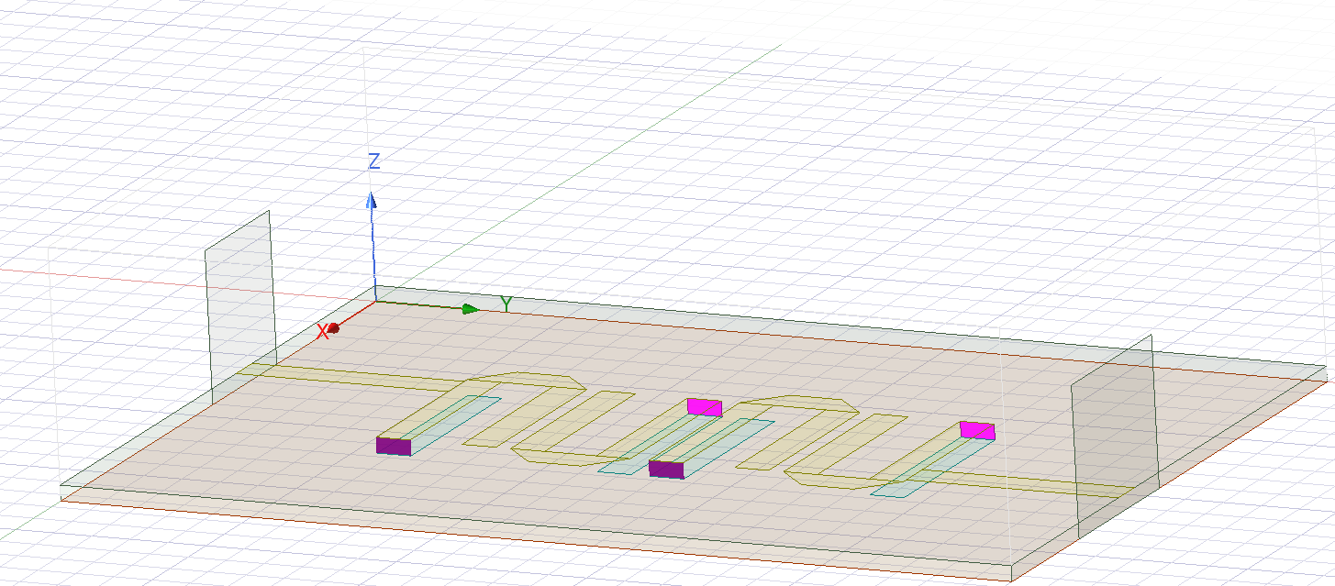

Additional Tuning Ports Placement

Once we have simulated the 6-port network, we can generate the S6P file and tune it in ANSYS designer software.



Tuning 6-Port circuit in designer software; values in picofarads.

We can tune internal coupling by placing a capacitor between the ports and we can tune the length of the resonator with capacitors connected to ground. To obtain the values shown the figure, I used the optimization tool of the designer software, specifically, pattern search.

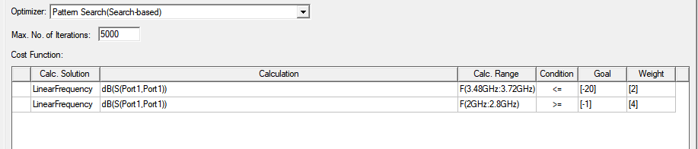

Optimization Setup

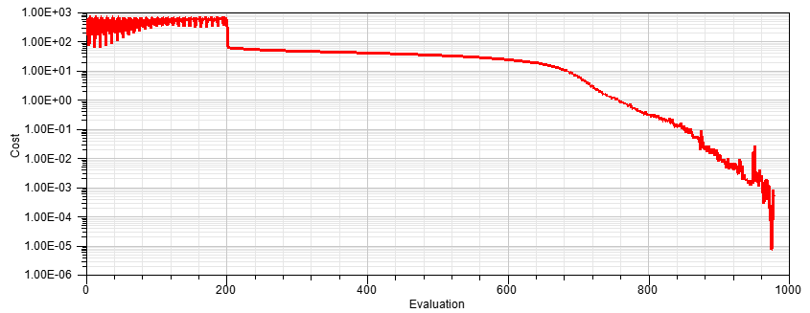

Evolution of Cost Function

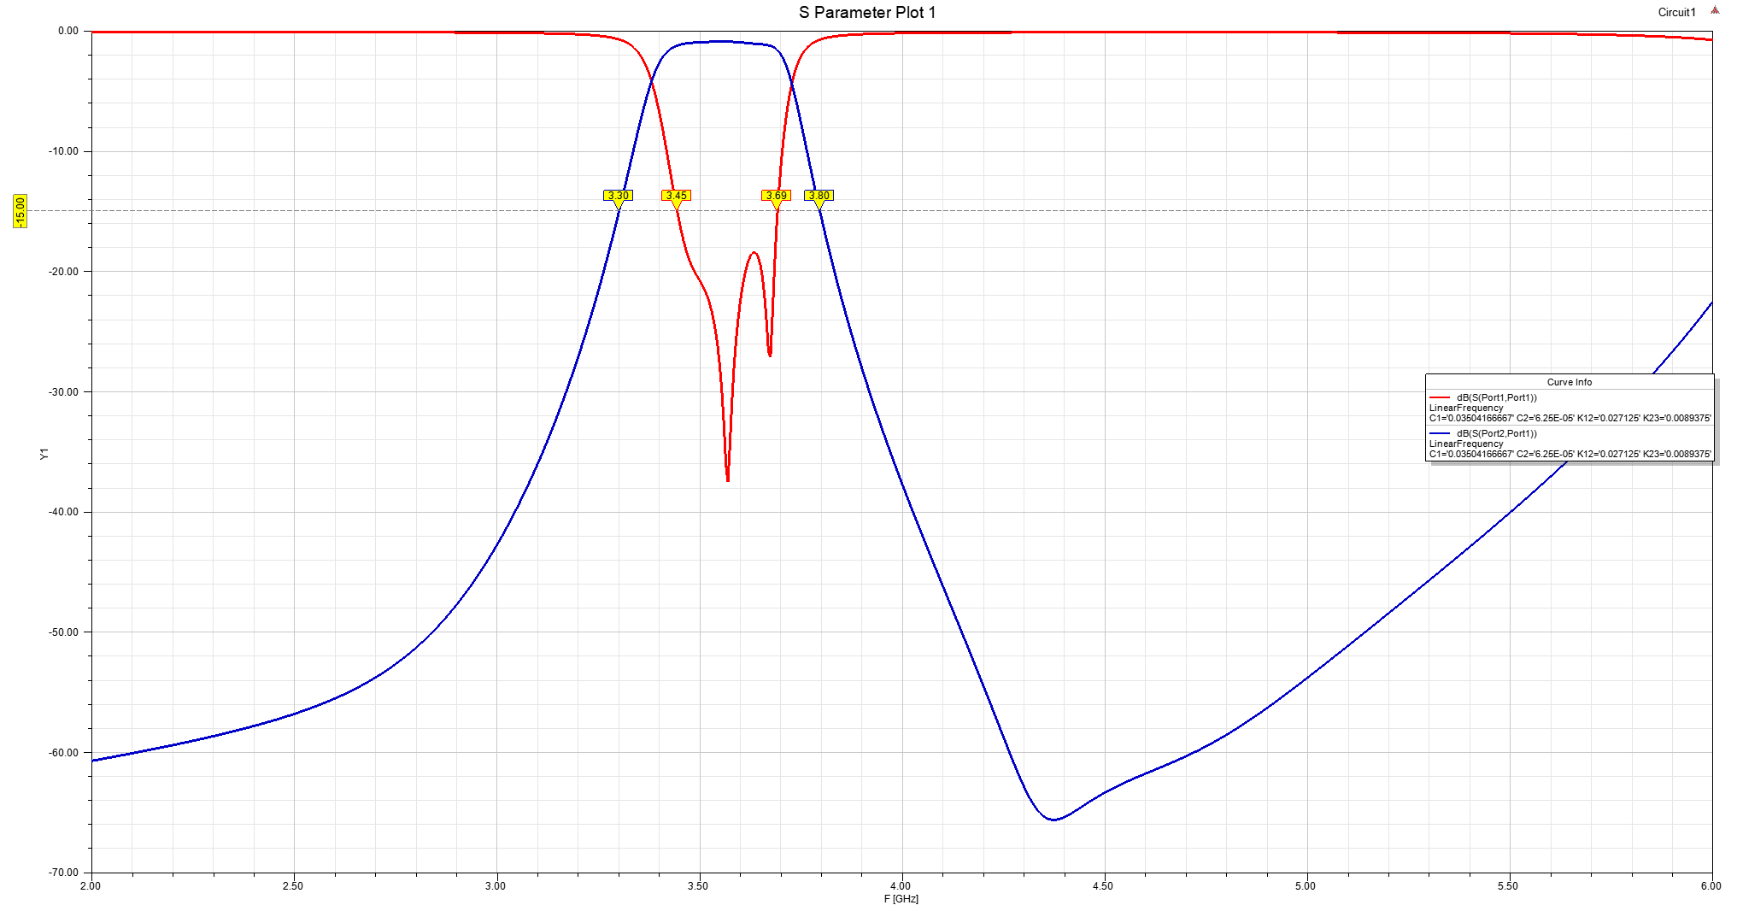

Tuned Filter Response

Although, the filter passband is below -15 dB, but the specification also requires having equal ripple, so I tried another approach of performing the same optimization but this time on the actual structure.

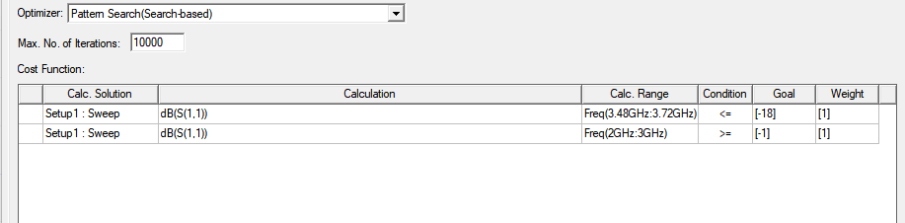

Optimization Setup

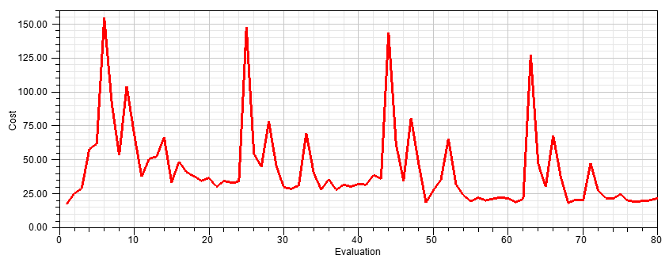

Evolution of Cost Function

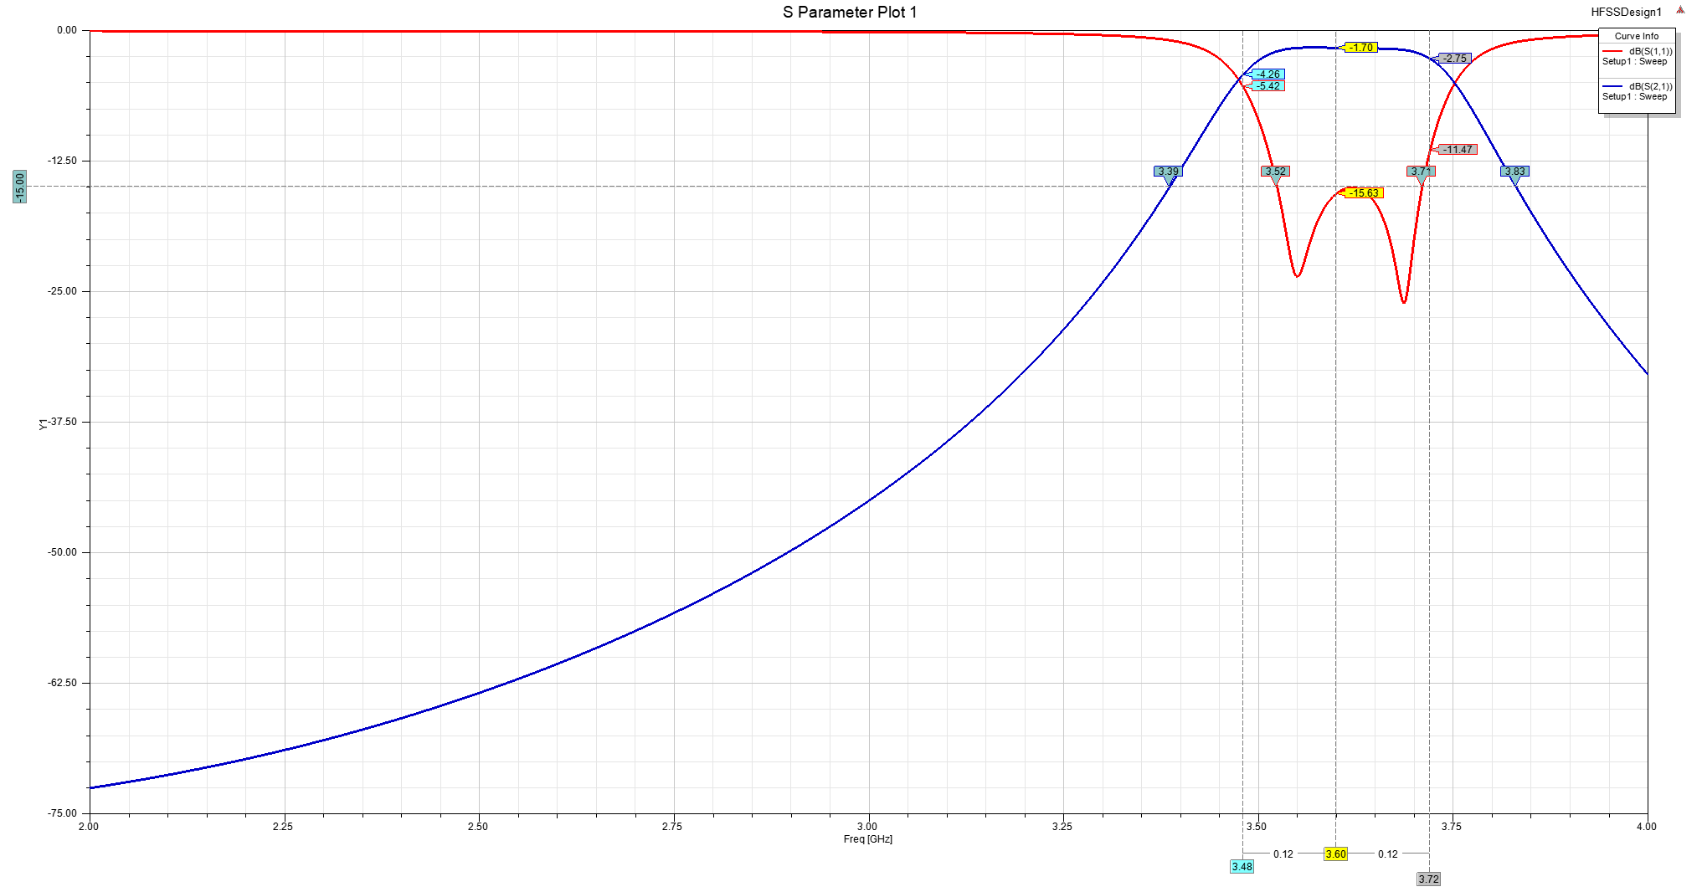

Tuned Filter Response

# Final Layout

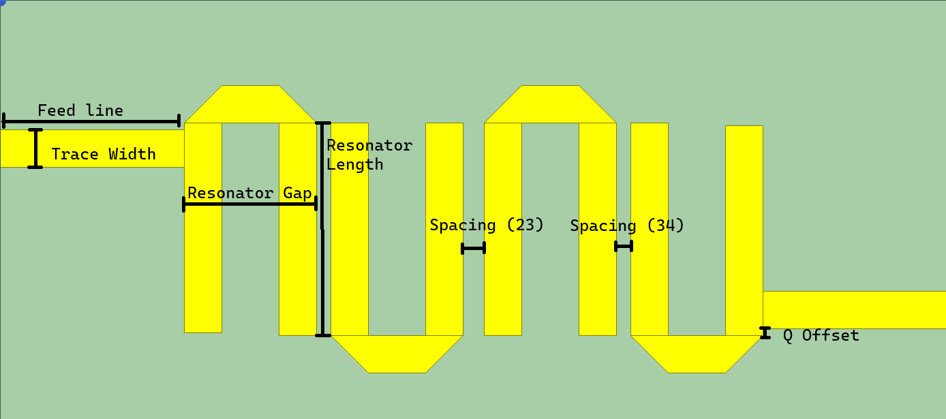

Final Layout

|  |  |
| --- | --- |
| Property | Size (mm) |
| Resonator Gap | 6.29 |
| Resonator Length | 9.98 |
| Trace Width (50 $Ω$) | 1.78 |
| Feed Line Length | 8.75 |
| External Coupling Offset | 0.34 |
| Internal Coupling Spacing (12 and 34) | 0.67 |
| Internal Coupling Spacing (23) | 1.01 |

# Encountered Difficulties

A common problem I encountered in filter synthesis was inconsistent simulation results. For example, for internal coupling coefficients, I would sometimes get random coupling values, this was due to low pass count (15 passes). Increasing the pass count from 15 to 18 passes seemed to resolve this issue and filter synthesis was much easier after this change. However, this realization took a considerable amount of time to figure out and therefore, I did not have as much time to tune the filter. I finished tuning the filter at 5:35 AM, 12/9/2023, Saturday (4 hours before fabrication time).

# Filter Fabrication and Comparison to Simulation

Filter fabrication took place on Saturday 12/9/2023 at 10:00 AM until 6:40 PM.

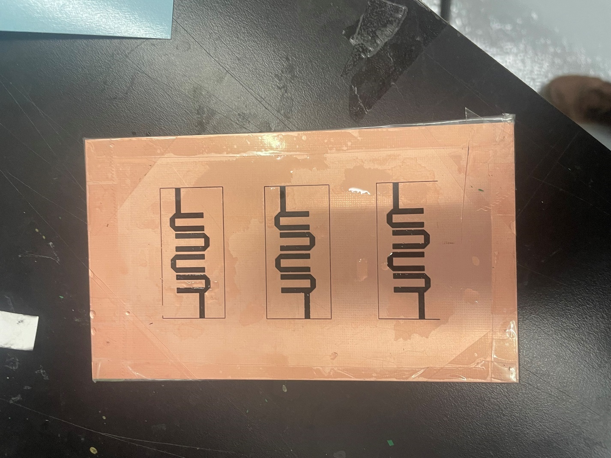

Lamented Roger’s 4003C Board

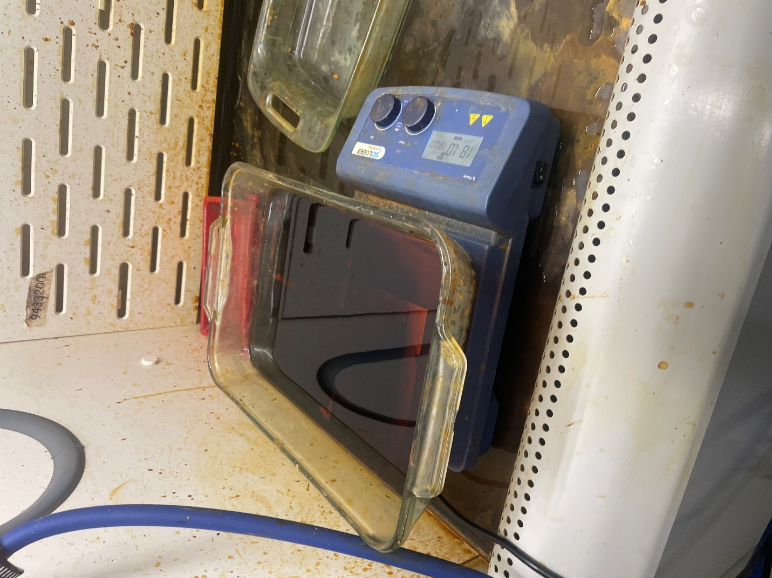

PCB Etching

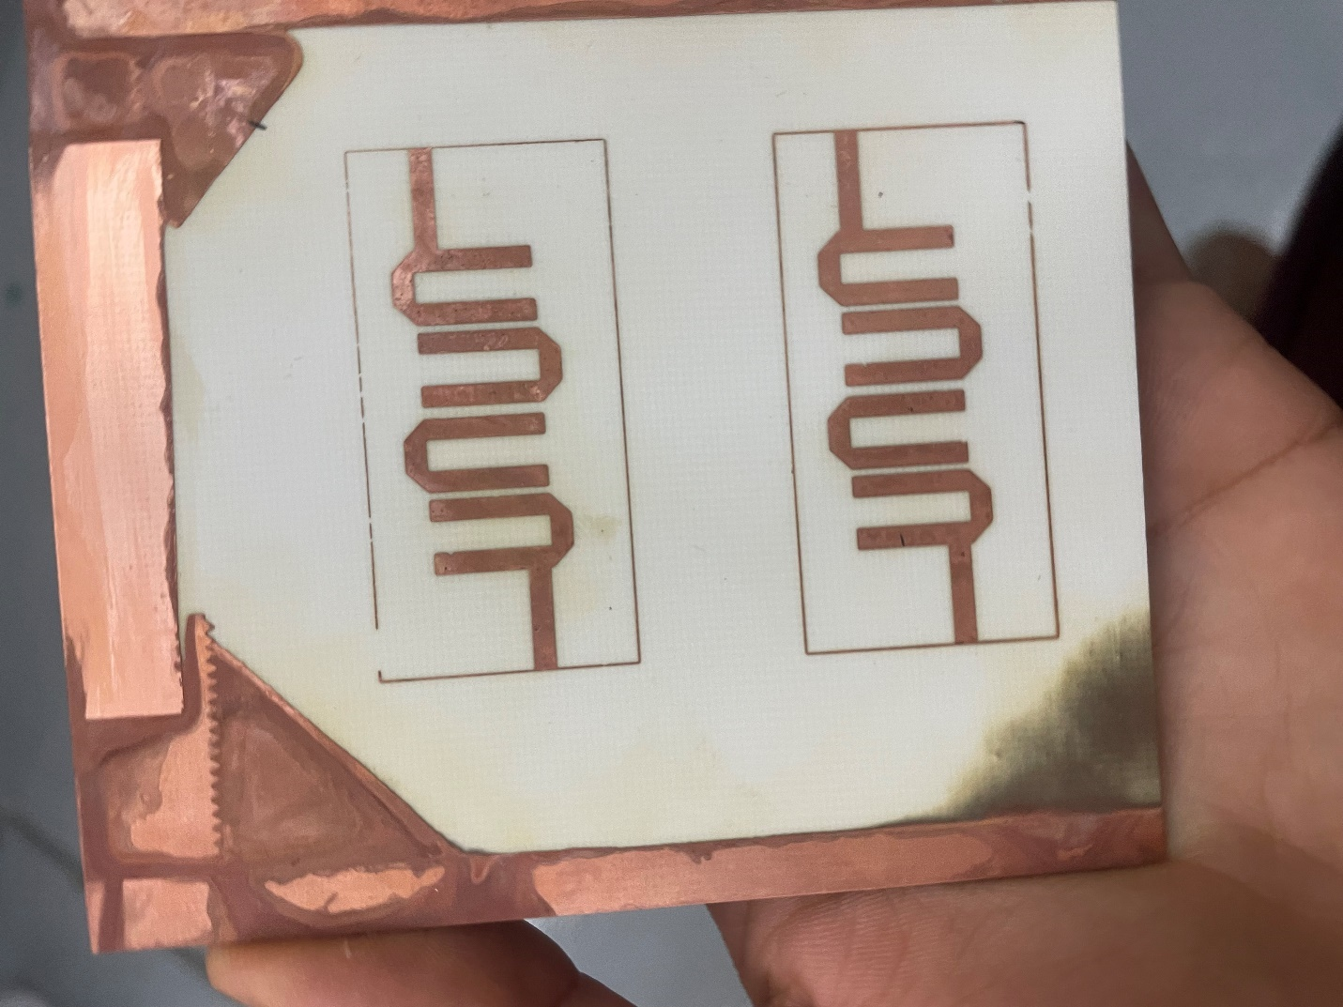

PCB After Etching and Removal of Ink

Unfortunately, my filter was over-etched, however, I do not know the level of over-etching due to lack of experience with etching PCBs.

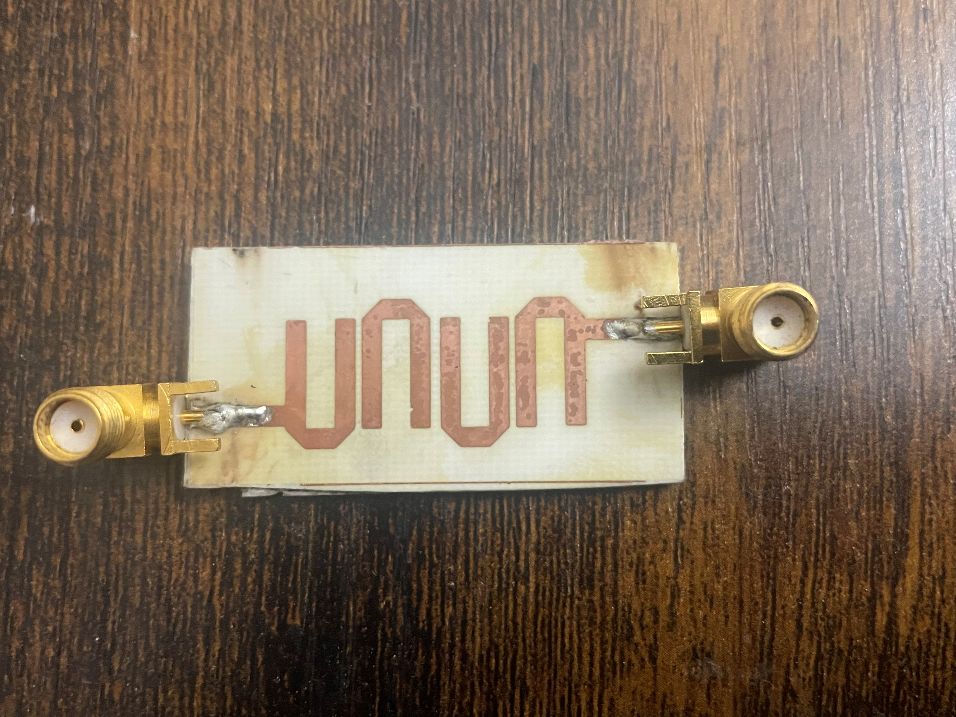

Filter 1 (Front)

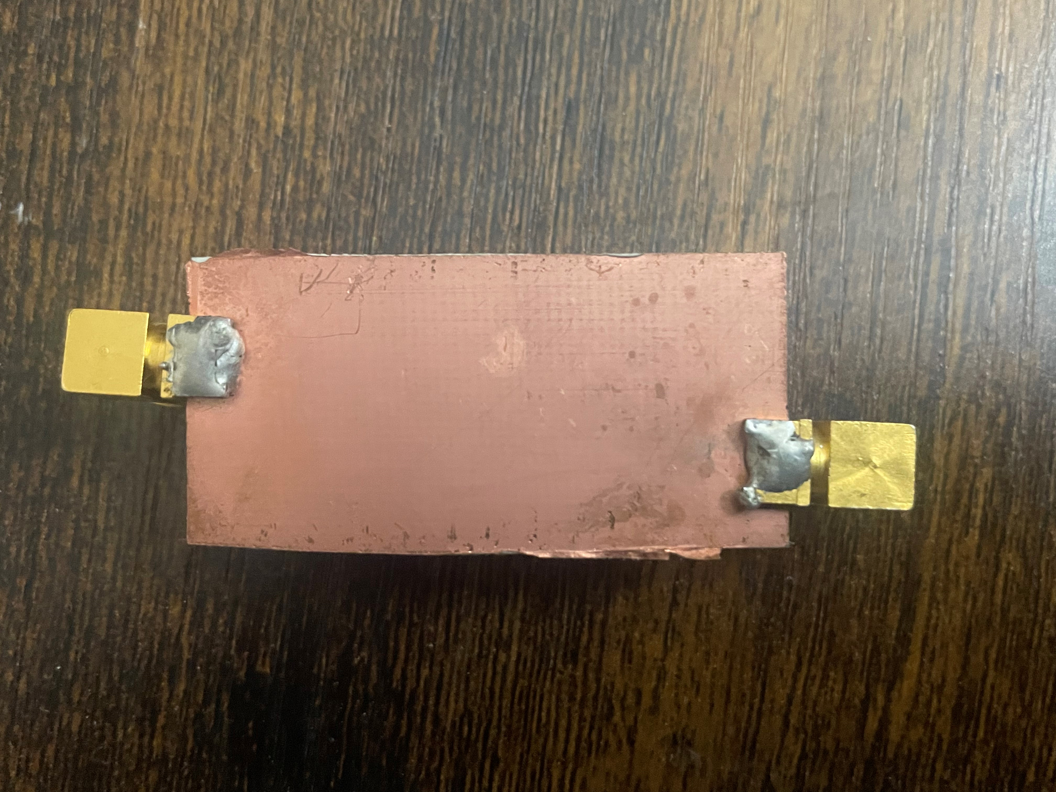

Filter 1 (Back)

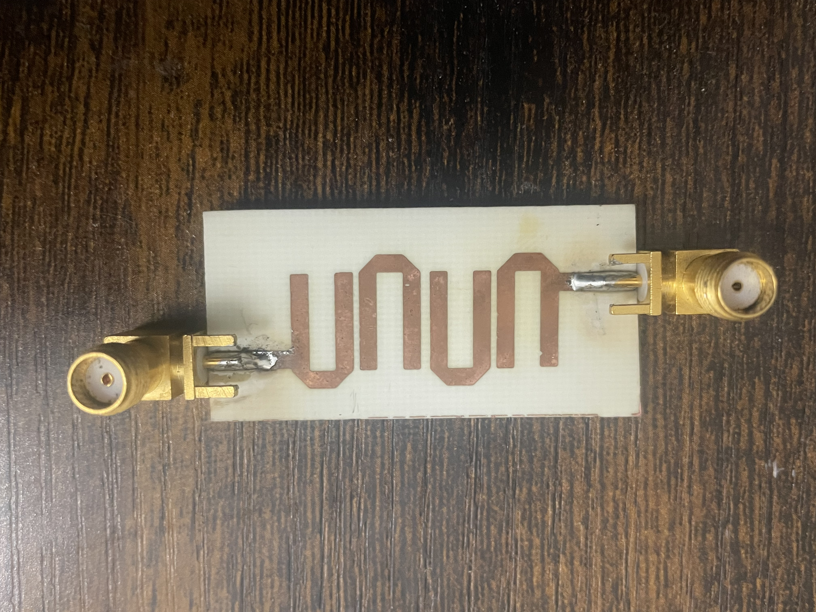

Filter 2 (Front)

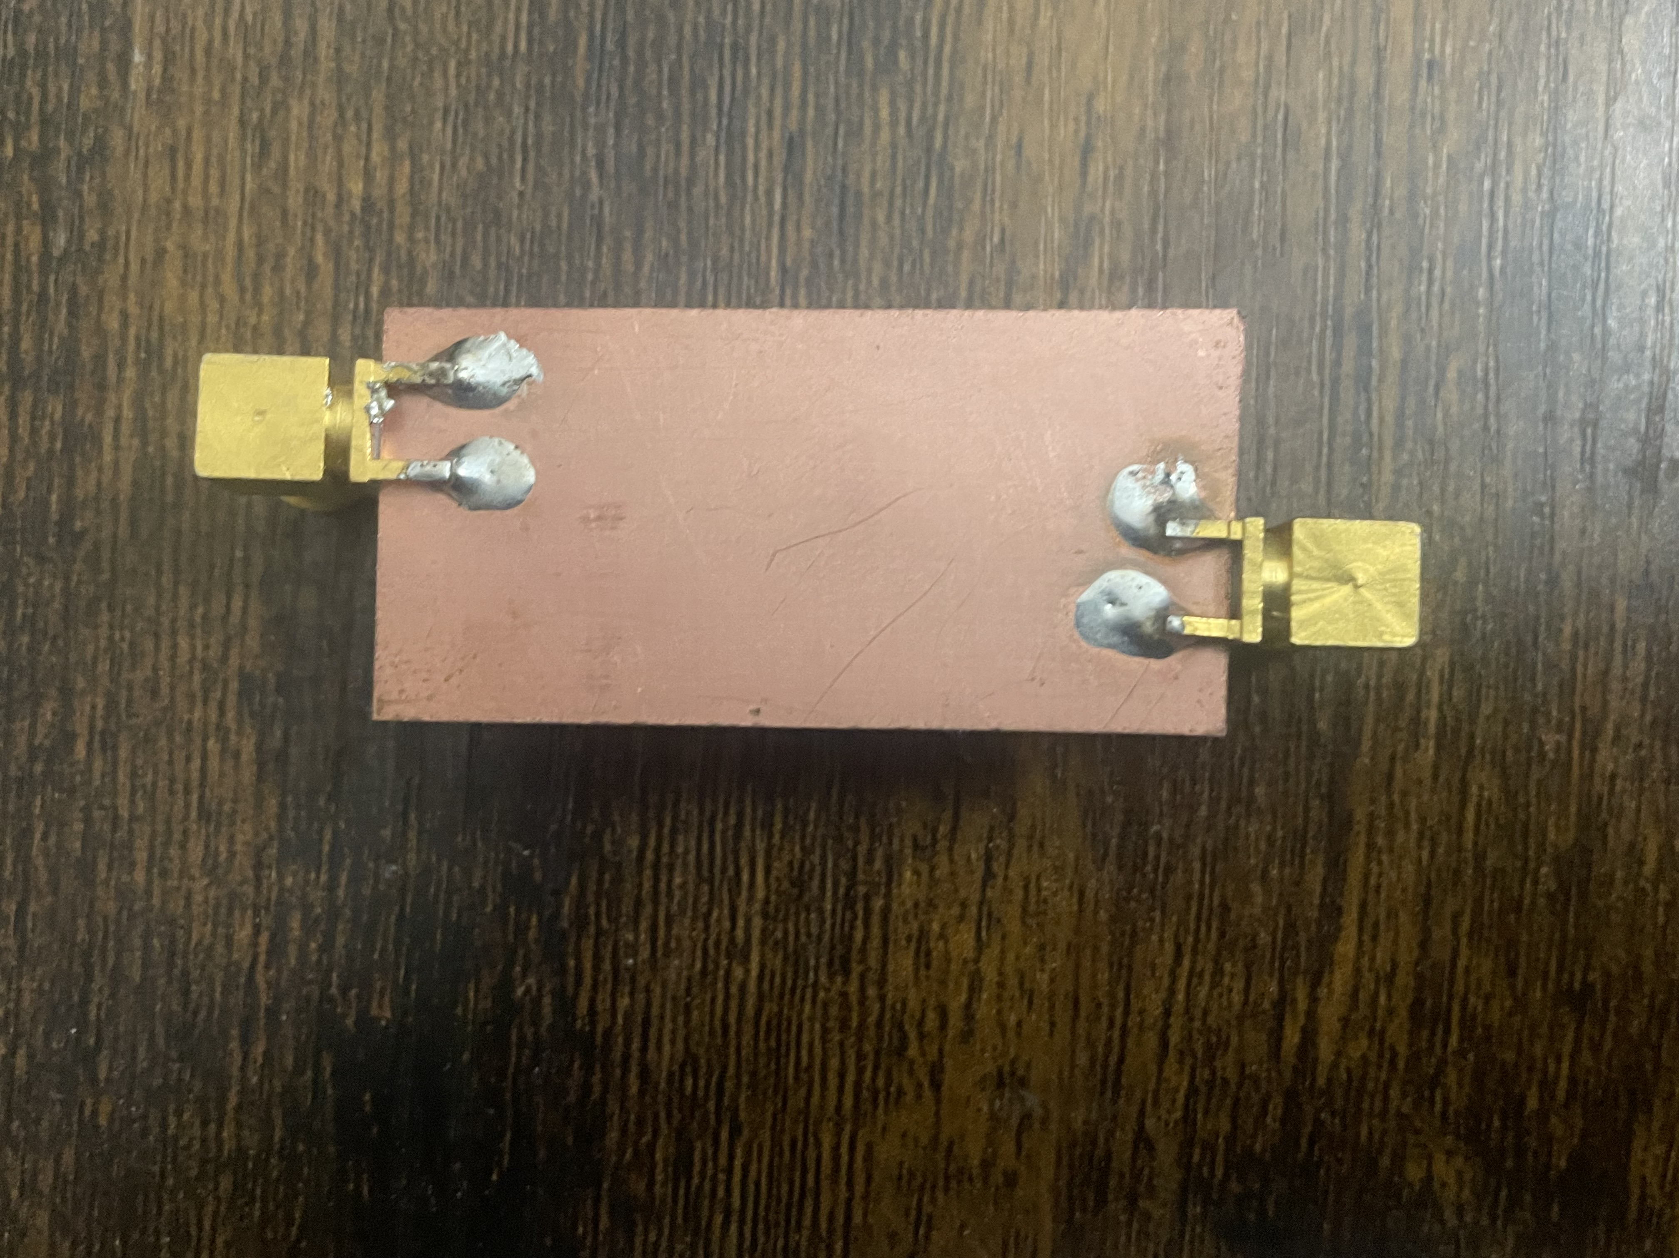

Filter 2 (Back)

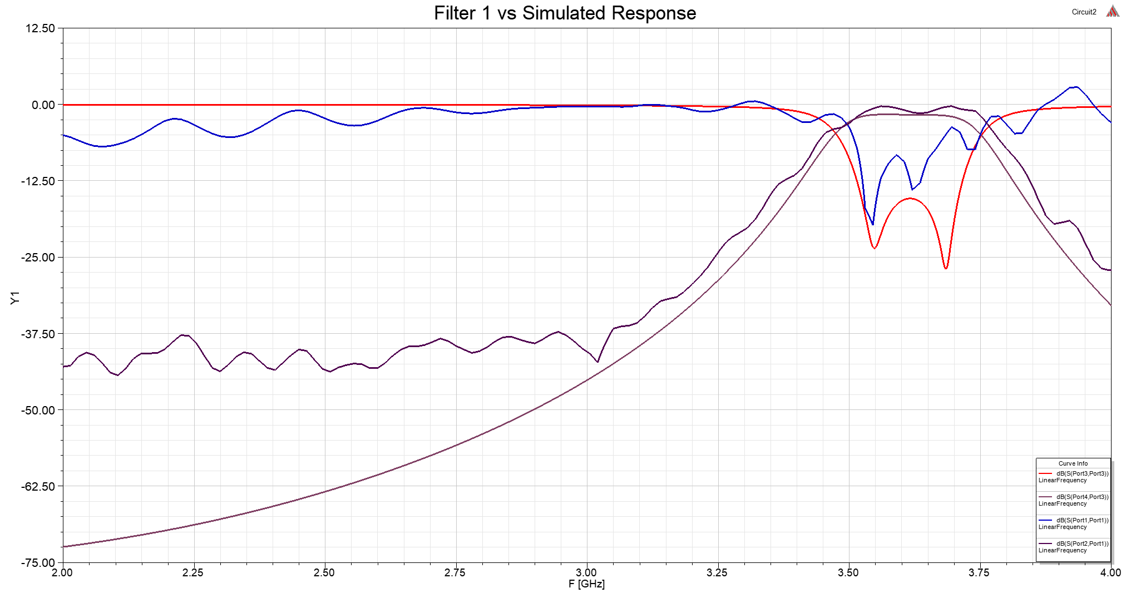

Filter 1 vs Simulated Response

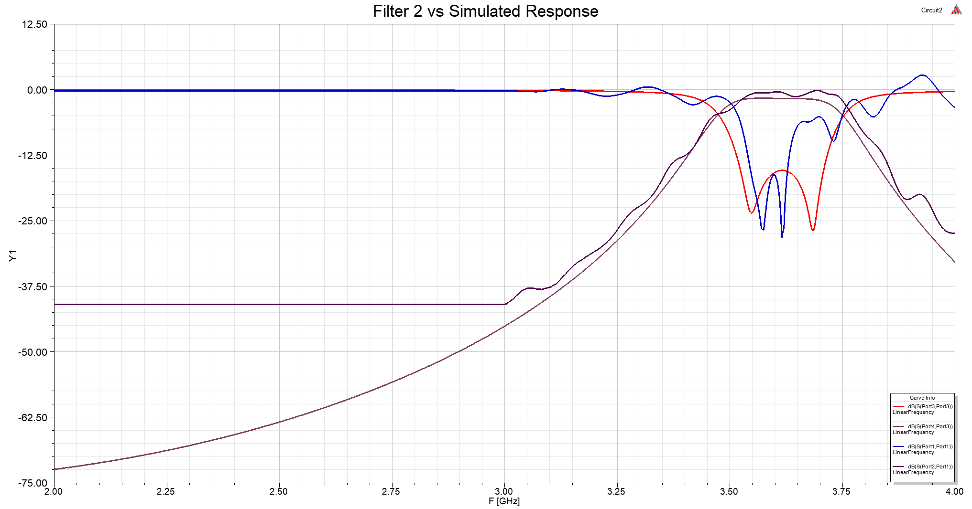

Filter 2 vs Simulated Response

# 5.0 Code

Program 1 (C++), Used to extract S21 peaks for resonator synthesis.

#include <iostream>

#include <fstream>

#include <vector>

#include <string>

#include <sstream>

#include <iomanip>

#include <map>

using namespace std;

vector<string> read_file(const string& filename) {

    // Open the file

   ifstream file(filename);

    // Check if the file is open successfully

    if (!file.is_open()) {

        std::cerr << "Error opening file: " << filename << std::endl;

        exit(-1);

    }

    // Read the file into a vector of strings

    vector<string> lines;

    string line;

    while (getline(file, line)) {

        lines.push_back(line);

    }

    // Close the file

    file.close();

    return lines;

}

vector<string> split_string(const std::string& input) {

    // Create an input string stream from the input string

   istringstream ss(input);

    // Vector to store the tokens

   vector<string> tokens;

    // Tokenize the string based on commas

   string token;

    while (getline(ss, token, ',')) {

        tokens.push_back(token);

    }

    return tokens;

}

vector<double> read_csv(const std::string& filename, int& outColumnCount) {

    outColumnCount = -1;

    auto lines = read_file(filename);

    outColumnCount = split_string(lines[0]).size();

    vector<double> data;

    for (const auto& line : lines) {

        try {

            const auto& cells = split_string(line);

            for (size_t i = 0; i < outColumnCount; i++) {

                data.push_back(stod(cells[i]));

            }

        }

        catch (...) {}

    }

    return data;

}

void save_file(const std::string& filename, const std::string& content) {

    // Open the file for writing

    std::ofstream outputFile(filename);

    // Check if the file is open successfully

    if (outputFile.is_open()) {

        // Write the string to the file

        outputFile << content;

        // Close the file

        outputFile.close();

       cout << "String successfully written to file: " << filename << endl;

    }

    else {

       cerr << "Error opening file for writing: " << filename << endl;

    }

}

int main() {

    auto column_count = 0;

    auto data = read_csv("S21_Resonator_Synthesis.csv", column_count);

    auto row_count = data.size() / column_count;

    // bridger2, leg1       frequency, S21 dB

    map<pair<double, double>, pair<double, double>> center_frequency;

    for (size_t i = 0; i < row_count; i++) {

        pair<double, double> parameter = { data[i * column_count + 0], data[i * column_count + 1] };

        double freq = data[i * column_count + 2];

        double s21 = data[i * column_count + 3];

        if (center_frequency.contains(parameter)) {

            auto& [current_freq, current_s21] = center_frequency[parameter];

            if (s21 > current_s21) {

                current_freq = freq;

                current_s21 = s21;

            }

        }

        else {

            center_frequency[parameter] = { freq, s21 };

        }

    }

    cout << fixed << showpoint;

    cout << setprecision(4);

    cout << "| Gap |  Length  |  f0  | S21 dB |\n";

    string csv = "Gap,Length,f0,S21 dB,\n";

    for (const auto& [parameters, peak] : center_frequency) {

        const auto& [bridge, leg] = parameters;

        const auto& [freq, s21] = peak;

        // exclude sweep range limited peaks

        if (freq == 4.0)

            continue;

        cout << bridge << ", " << leg << ", " << freq << ", " << s21 << ",\n";

        csv += to_string(bridge) + ", " + to_string(leg) + ", " + to_string(freq) + ", " + to_string(s21) + ",\n";

    }

    save_file("data.csv", csv);

}

Program 2 (MATLAB), Used to interpolate optimal length for resonator synthesis.

% Gap240, .245, .252, .258, .265, .270, .275 definitions

% Store matrices in a cell array

dataCellArray = {Gap240, Gap245, Gap252, Gap258, Gap265, Gap270, Gap275};

f = figure;

f.Position = [100, 100, 1280, 720];

centerfig(f);

title("Length vs Center Frequency", "FontSize", 16);

xlabel("Length/(0.5*\lambda)","FontSize",14);

ylabel("Center Frequency", "FontSize", 14);

hold on;

grid on;

ylim([3.2, 4]);

% Access each set in a for loop

for i = 1:length(dataCellArray)

    currentSet = dataCellArray{i};

    % Extract x and y values

    len = currentSet(:, 1);

    center_freq = currentSet(:, 2);

    x = min(len):0.001:max(len);

    y = interp1(len, center_freq, x, 'linear');

    plot(x, y);

    plot(len, center_freq, '.', 'MarkerSize', 15);

    % Value for interpolation

    desired_freq = 3.6;

    % Check if desired frequency is within the range

    if desired_freq < min(center_freq) || desired_freq > max(center_freq)

        % Linear extrapolation

        extrapolated_length = interp1(center_freq, len, desired_freq, 'linear', 'extrap');

        % Plot the extrapolated point

        disp(['Extrapolated Spacing for f0 = ', num2str(desired_freq), ' is ', num2str(extrapolated_length), ' mm.']);

    else

        % Interpolation within the range

        try

        interpolated_length = interp1(center_freq, len, desired_freq, 'linear');

        yline(desired_freq, '--b', "Interpolated Length for f_{0} = " + desired_freq + " GHz");

        disp(['Interpolated Spacing for f0 = ', num2str(desired_freq), ' is ', num2str(interpolated_length), ' mm.']);

        catch ME

        end

    end

end

Program 3 (MATLAB), Used to interpolate internal and external coupling coefficients.

spacing = [...

];

k = [...

];

f = figure;

f.Position = [100, 100, 1280, 720];

centerfig(f);

x = min(spacing):0.001:max(spacing);

y = interp1(spacing, k, x, 'makima');

plot(x, y, '-');

title("Couling K vs Spacing", "FontSize", 16);

xlabel("Spacing (mm)","FontSize",14);

ylabel("Coupling K", "FontSize", 14);

hold on;

grid on;

ylim([0.025,0.15]);

xlim([0.0, 1.25]);

plot(spacing, k, '.', 'MarkerSize', 15);

% Value for interpolation

desired_k = 0.06204686;

desired_k2 = 0.047388633;

% Interpolate the offset value for the given Qext

interpolated_spacing = interp1(k, spacing, desired_k, 'makima');

interpolated_spacing2 = interp1(k, spacing, desired_k2, 'makima');

stem(interpolated_spacing, desired_k);

yline(desired_k, '-', "Spacing = " + interpolated_spacing + " mm, for k_{ij} = " + desired_k);

stem(interpolated_spacing2, desired_k2);

yline(desired_k2, '-', "Spacing = " + interpolated_spacing2 + " mm, for k_{ij} = " + desired_k2);

disp(['Interpolated Spacing for k = ', num2str(desired_k), ' is ', num2str(interpolated_spacing), ' mm.']);

disp(['Interpolated Spacing for k = ', num2str(desired_k2), ' is ', num2str(interpolated_spacing2), ' mm.']);

# Conclusion

In this project, the objective was the design and synthesis of a 4th order Chebyshev bandpass filter operating at 3.6 GHz. The objective included achieving a ripple bandwidth of 0.24 GHz and maintaining a passband S11 below -15 dB. The synthesis process involved resonator design, simulation, tuning, and fabrication.

Filter synthesis incorporated the selection of a lowpass prototype table and subsequent construction of a bandpass filter. Internal coupling coefficients were computed using Chebyshev tables, and a symmetrical device structure was achieved through careful observation. The external coupling coefficient was then determined through simulation and measurement.

The tuning process involved the strategic placement of capacitors to adjust resonator length and internal coupling. The optimization tool in the ANSYS designer software, employing the pattern search algorithm, facilitated the fine-tuning process.

Filter fabrication encountered challenges, notably over-etching, reflecting a learning curve in the PCB etching process. The fabricated filters were compared to simulated responses, revealing some discrepancies, possibly attributed to fabrication issues.

Throughout the project, the iterative nature of microwave filter design was evident, with challenges emerging at various stages. The optimization of simulation parameters, resonator dimensions, and coupling coefficients required a careful balance to achieve the desired filter characteristics. Despite facing challenges, the project was successfully concluded, and the fabricated filter demonstrated an initial agreement with the simulated response.

This project provided valuable insights into the complexities of microwave filter design, emphasizing the importance of simulation, optimization, and experimental validation in achieving desired performance specifications.

# Sources

[1] Narrow-Band Microwave Filter Design by Dr. Daniel G. Swanson, Jr.

[2] Microwave Engineering by David. M Pozar

[3] Dr. Xun Gong Lectures